**List Of Observable Trends:**

* Wind Speed does not affect according to the distance of the cities from the Equator.it is usually below 20mph in majority of the Cities.

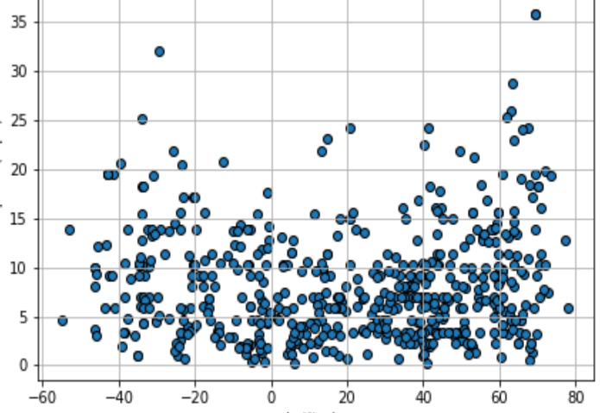

* Temperature Increases for the cities when the latitude of the cities is nearby the equator.

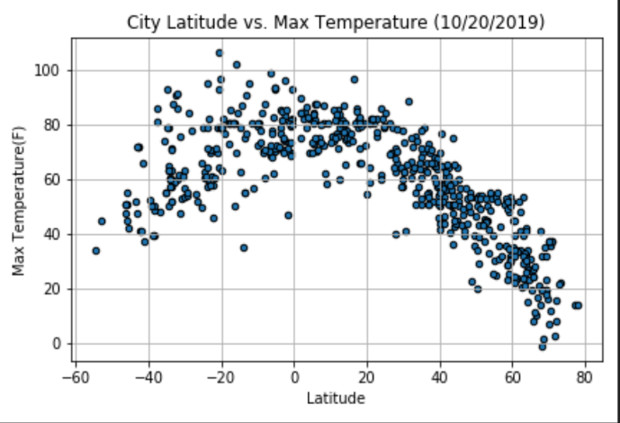

* Humidity for the cities also have no effect according to the Equator. It’s Percentage is usually about 60 for most of the cities.

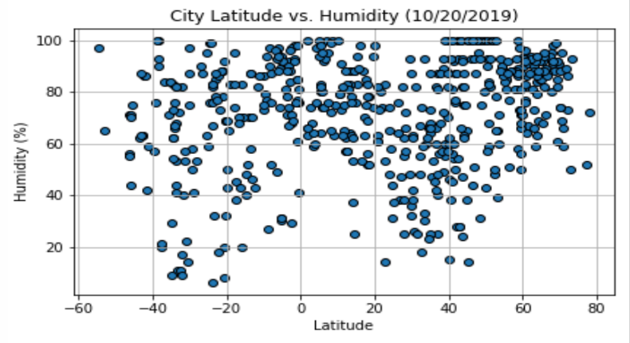

* There is no fixed range where cloudiness lies for the cities. Straight line is observed for most countries having 0 Percent cloudiness and 100 Percent cloudiness.